**GANPAT UNIVERSITY**

**U.V.PATEL COLLEGE OF ENGINEERING & TECHNOLOGY**

**Department of Computer Science and Engineering**

**B.Tech 1ST Semester   Subject – Essentials Of Software Foundation and programming**

**First Name: Varun Mehta      Enrollment Number: t14012111002                      Stream: Mobile Applications**

**Assignment-1 Date: 27-08-14**

**1. Write a program to print ASCII values of all backslash characters and white space on screen in following format :**

**The ASCII value of ‘\t’ is : 9**

**(Hint : you can verify your ASCII values with the help of a table for ASCII values from text book)**

**ANS:**

#include<stdio.h>

#include<conio.h>

void main()

{

clrscr();

printf("ASCII value of \'a\' is:%d\n",'\a');

printf("ASCII value of \'b\' is%d\n",'\b');

printf("ASCII value of \'f\' is%d\n",'\f');

printf("ASCII value of \'n\' is%d\n",'\n');

printf("ASCII value of \'r\' is%d\n",'\r');

printf("ASCII value of \'t\' is%d\n",'\t');

printf("ASCII value of \'v\' is%d\n",'\v');

printf("ASCII value of '' is %d\n",'\"');

printf("ANSCI value of \'\?\' is %d\n",'\?');

printf("ASCII value of \'\\\' is %d\n",'\\');

printf("ASCII value of \'10\' is%d\n", '10');

getch();

}

**OUTPUT:**

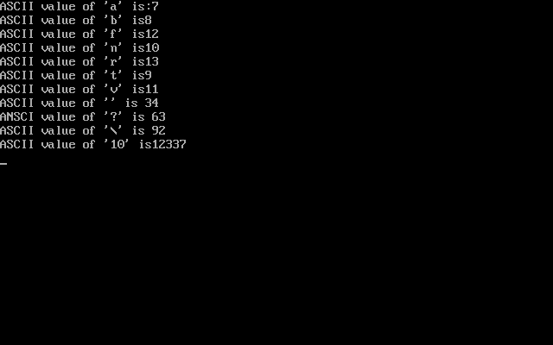

**2. Explain different data types available in C.**

**ANS:**

C has the following basic built-in datatypes.

* int
* float
* double
* char

**int** ---> key word is used to declare Integer variables.   
  
Eg:   
int a, b;   
  
here the variables a and b can hold only the integer value (ie., whole numbers only)   
  
**float** ---> key word is used to declare Real numbers or floating point numbers.   
  
Eg:   
float x, y;   
  
Here the variables x and y can hold only the real or floating point numbers (ie., numbers with decimal point)   
  
**char** ---> key word is used to declare characters or string.   
  
Eg:   
char ch;   
  
Here the variable ch can store a single character.   
  
**double** ---> key word is used to declare a variable which can hold a large number.   
  
Eg:   
double z;

**3. Explain about C Tokens in brief.**

 In a C source program, the basic element recognized by the compiler is the "token." A token is source-program text that the compiler does not break down into component elements.

* Keywords: keywords are defined by the software with the specified meaning.

In c language [32 keywords](http://yellowpen.co.in/c_Notes/keywords.html) are there

|  |  |  |
| --- | --- | --- |
| **Example: double,** | **int,** | **struct, etc** |

* Identifiers: User defined variable names.
* Constants: The value which is not changed during the execution
* Strings: Group of characters enclosed in " "
* Operators: The following are the operators available in c

1. Arthematic Operators: [+,-,*,/,%]

2. Assignment Operators: [=]

3. Relational Operators: [<,<=,>,>=,==,!=]

4. Logical Operators: [and, or, not]

5. increment/decrement Operators: [++,--]

6. Bitwise Operators: [&,|,~,^,>>,<<]

7. Conditional or ternary Operator:[?:]

* Special characters: ,(comma) -to separate
* 2 variables sizeof Operators -returns the size of the variable

**4. Explain about backslash characters in C.**

ANS:

* + There are some characters which have special meaning in C language.
  + They should be preceded by backslash symbol to make use of special function of them.
  + Given below is the list of special characters and their purpose.

|  |  |
| --- | --- |
| Backslash character | Meaning |
| \b | Backspace |
| \f | Form feed |
| \n | New line |
| \r | Carriage return |
| \t | Horizontal tab |
| \” | Double quote |
| \’ | Single quote |
| \\ | Backslash |
| \v | Vertical tab |
| \a | Alert or bell |
| \? | Question mark |